**String Class:**

1. **import** java.util.Scanner;

**public** **class** hello {

**public** **static** **void** main(String[] args) {

// **TODO** Auto-generated method stub

String str = "Hello World";

**int** i= str.length();

System.***out***.print(i);

}

}

**Output:**

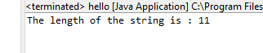

1. **import** java.util.Scanner;

**public** **class** hello {

**public** **static** **void** main(String[] args) {

// **TODO** Auto-generated method stub

String str = "Hello,";

String str1 = "How are you?";

System.***out***.print(str + str1);

}

}

**Output:**

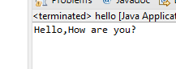

**3.**

**a)**

**import** java.util.Scanner;

**public** **class** hello {

**public** **static** **void** main(String[] args) {

// **TODO** Auto-generated method stub

String str = "Java String pool refers to collection of Strings which are stored in heap memory";

System.***out***.print(str.toLowerCase());

}

}

**Output:**

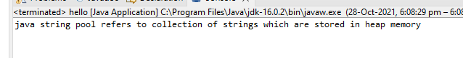

**b)**

**import** java.util.Scanner;

**public** **class** hello {

**public** **static** **void** main(String[] args) {

String str = "Java String pool refers to collection of Strings which are stored in heap memory";

System.***out***.print(str.toUpperCase());

}

}

**Output:**

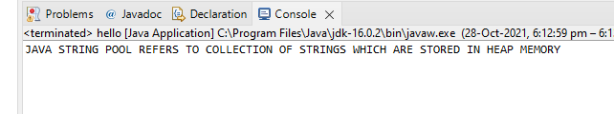

**c)**

**import** java.util.Scanner;

**public** **class** hello {

**public** **static** **void** main(String[] args) {

String str = "Java String pool refers to collection of Strings which are stored in heap memory";

System.***out***.print(str.replace("a", "$"));

}

}

**Output:**

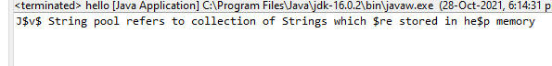

**d)**

**import** java.util.Scanner;

**public** **class** hello {

**public** **static** **void** main(String[] args) {

String str = "Java String pool refers to collection of Strings which are stored in heap memory";

**if**(str.contains("collection"))

{

System.***out***.print("Yes, the word is present");

}

**else**

{

System.***out***.print("No, the word is not present");

}

}

}

**Output:**

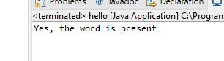

**e)**

**import** java.util.Scanner;

**public** **class** hello {

**public** **static** **void** main(String[] args) {

String str = "Java String pool refers to collection of Strings which are stored in heap memory";

String str1 = "java string pool refers to collection of strings which are stored in heap memory";

**if**(str == str1)

{

System.***out***.print("Yes, Both the string are same");

}

**else**

{

System.***out***.print("No, Both the string are not same");

}

}

}

**Output:**

**3e.PNG**

**f)**

**import** java.util.Scanner;

**public** **class** hello {

**public** **static** **void** main(String[] args) {

String str = "Java String pool refers to collection of Strings which are stored in heap memory";

String str1 = "java string pool refers to collection of strings which are stored in heap memory";

String s= str.toLowerCase();

**if**(s.equals(str1))

{

System.***out***.print("Yes, Both the string are same");

}

**else**

{

System.***out***.print("No, Both the string are not same");

}

}

}

**Output:**

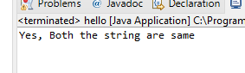

**StringBuffer Class:**

1. **import** java.util.Scanner;

**public** **class** hello {

**public** **static** **void** main(String[] args) {

StringBuffer s = **new** StringBuffer("StringBuffer");

s.append(" is a peer class of String");

s.append(" that provides much of");

s.append(" the functionality of strings");

System.***out***.print(s);

}

}

**Output:**

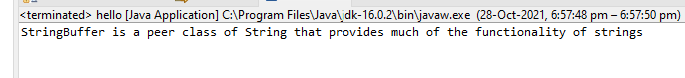

1. **import** java.util.Scanner;

**public** **class** hello {

**public** **static** **void** main(String[] args) {

StringBuffer s = **new** StringBuffer("It is used to at the specified index position");

s.insert(14, "insert text ");

System.***out***.print(s);

}

}

**Output:**

**s2.PNG**

1. **import** java.util.Scanner;

**public** **class** hello {

**public** **static** **void** main(String[] args) {

StringBuffer s = **new** StringBuffer("This method returns the reversed object on which it was called");

s.reverse();

System.***out***.print(s);

}

}

**Output:**

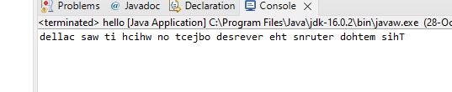

**StringBuilder Class:**

1. **import** java.util.Scanner;

**public** **class** hello {

**public** **static** **void** main(String[] args) {

StringBuilder s = **new** StringBuilder("StringBuffer");

s.append(" is a peer class of String");

s.append(" that provides much of");

s.append(" the functionality of strings");

System.***out***.print(s);

}

}

**Output:**



1. **import** java.util.Scanner;

**public** **class** hello {

**public** **static** **void** main(String[] args) {

StringBuilder s = **new** StringBuilder("It is used to at the specified index position");

s.insert(14, "insert text ");

System.***out***.print(s);

}

}

**Output:**

**s2.PNG**

1. **import** java.util.Scanner;

**public** **class** hello {

**public** **static** **void** main(String[] args) {

StringBuilder s = **new** StringBuilder("This method returns the reversed object on which it was called");

s.reverse();

System.***out***.print(s);

}

}

**Output:**

